**Lab – 10**

**SQL query based on DDL -2**

1. **Write a Query to Alter the table employee with multiple columns (EMPNO, ENAME.)**

ALTER TABLE employees

ADD( EMPNO NUMBER(10),

ENAME VARCHAR(100));

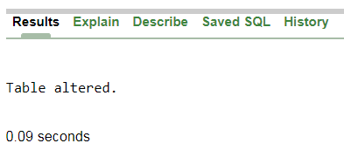

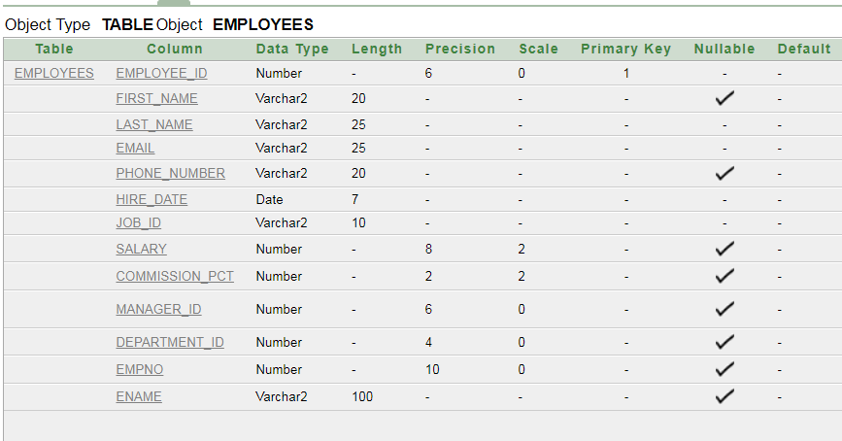

1. **Write a query to add a new column in to employee.**

ALTER TABLE employees

ADD (city NUMBER(10));





1. **Write a query to add multiple columns in to employee.**

ALTER TABLE employees

ADD (address_2 VARCHAR(100),

telephone_no VARCHAR(15),

hire_date_2 DATE);



1. **Write a query to drop a column from an existing table employee.**

ALTER TABLE employees

DROP COLUMN hire_date_2;



1. **Write a query to rename table emp to employee.**

ALTER TABLE employees

RENAME TO emp;

